 VINOD SIR’S GROUP TUTION

MARKS: 24 MATHS-VIII TIME: 1 Hr. 30 Mins.

Q. 1: [8] 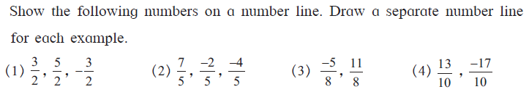

Q. 2: [3] 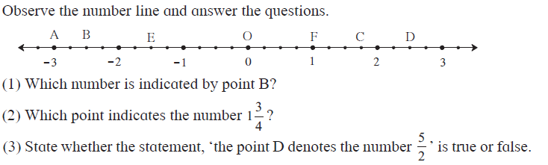

Q. 3: Compare the following: [3]

1 -8 , -5 2. , 7 3. , 4. ,

Q. 4: Write the following rational numbers in decimal form: [2]
1. 2.
Q. 5: Say what type of number they are: [2]
1. 1, 2,3,4,5…………… 2. 0,1,2,3,4, ...
3. ...,-4,-3,-2,-1, 0, 1, 2, 3,... 4. -13/10, 10/-5, -6, 3, 5, 32/13, etc

Q. 6: 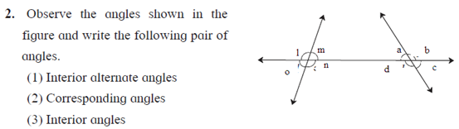[3]

Q: 7: 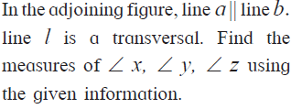 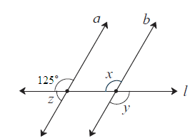[3]

